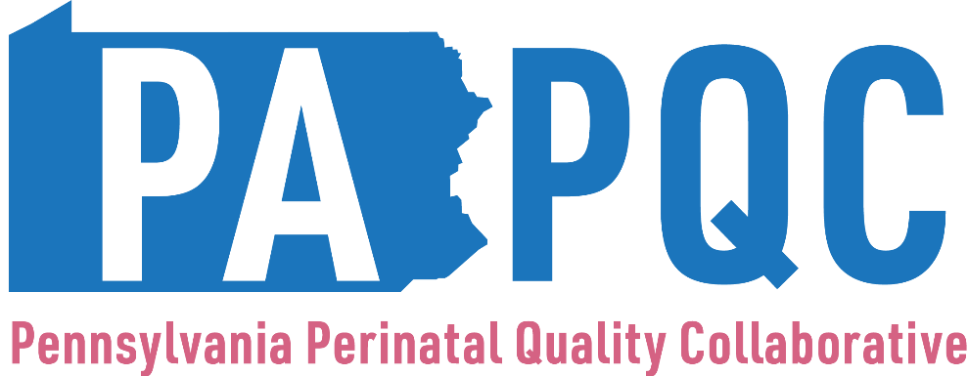

Maternal Substance Use Survey
(Structure Measures)

Please work with your team to complete this birth site-level survey for the designated quarter, starting with January through March 2022.

- What is your PA PQC Hospital or Affiliation? (dropdown list)

- What is your name? (text box)

- What is your title/role? (text box)

- Has your hospital developed trauma-informed protocols in the context of substance use? (e.g., for example, please see https://www.samhsa.gov/sites/default/files/programs_campaigns/childrens_mental_health/atc-whitepaper-040616.pdf)

Multiple Choice:
  - Yes (in place)
  - No (Working on it)
  - No (have not started)

- Does your hospital provide anti-racist training for providers, staff, and leadership?

Multiple Choice:
  - Yes (in place)
  - No (Working on it)
  - No (have not started)

(Description: Anti-racist training is defined as a training that focuses on the “active process of identifying and eliminating racism by changing systems, organizational structures, policies and practices and attitudes, so that power is redistributed and shared equitably.” The trainings also use this lens to address topics that are also often included in Diversity, Equity, and Inclusion trainings, such as unconscious and implicit bias, the meaning of diversity, equity and inclusion, stereotyping, reducing prejudice, cultural awareness and belonging, addressing microaggressions, and anti-harassment.)

- Does your hospital provide training for clinical and non-clinical staff on substance use among pregnant and postpartum individuals that also explores and addresses health care team members’ biases and stigma related to substance use?

Multiple Choice:
  - Yes (in place)
  - No (Working on it)
  - No (have not started)

(Description: Clinical and Non-Clinical Staff education and training should emphasize SUDs are chronic medical conditions that can be treated, stigma, bias and discrimination negatively impact pregnant people with SUD and their ability to receive high quality care, providers should match treatment response to each person’s stage of recovery and/or readiness to change, and federal, state, and local notification guidelines for infants with in-utero substance exposure and comprehensive family care plan requirements. This training should include trauma-informed care, naloxone and harm reduction strategies, regional and local data on SUDs, and regional and local support services, programs, and resources. Obstetric providers should consider receiving training on outpatient treatment of SUD, including MOUD (buprenorphine) to improve access to care.)

- Does your hospital have evidence-based education materials focused on substance use in pregnancy and the caregiver’s role in Substance Exposed Newborn care?

Multiple Choice:
  - Yes (in place)
  - No (Working on it)
  - No (have not started)
If Yes, please check which substances that education materials address:
  - Opioids
  - Sedatives
  - Stimulants (Cocaine and Amphetamines)
  - Alcohol
  - Tobacco
  - Marijuana
  - Other (If you select other, please specify which substance(s) your educational materials address)

- Does your hospital provide education to pregnant and postpartum people related to naloxone use?

- Multiple Choice:
  - Yes (in place)
  - No (Working on It)
  - No (have not started)

- Does your hospital have a system in place to provide naloxone to patients prior to discharge?

- Multiple Choice:
  - Yes (in place)
  - No (Working on It)
  - No (have not started)

- Does your site use a validated, self-report screening tool for substance use in pregnancy?

- Multiple Choice:
  - Yes (in place)
  - No (Working on It)
  - No (have not started)

- If yes, please check the validated screening tool that is being used:
- 4Ps
- 4Ps Plus©
- 5Ps or Integrated 5Ps Screening Tool
- NIDA Quick Screen (and if positive, the NIDA-Modified ASSIST)
- Substance Use Risk Profile Pregnancy (SURP-P) Scale
- CRAFFT (for adolescents)
- Wayne IDUS
- DAST-10
- Prenatal Risk Overview-Drug Use (PRO)
- AUDIT (specific to alcohol)
- T-ACE (specific to alcohol)
- TWEAK (specific to alcohol)
- CRAFFT (specific to alcohol)
- Other (please name and describe the screen, and please specify which substances that tool screens for: opioids, sedatives, stimulants (cocaine and amphetamines), alcohol, tobacco, marijuana, and other)

- For pregnant/postpartum individuals who screen positive for substance use, does your site have protocols and team roles in place to provide brief interventions that offer feedback to patients, explore readiness for behavior changes, initiate goal-setting, and refer to treatment?

  - Yes (in place)
  - No (working on it)
  - No (have not started)

- Does your site provide Medications for Opioid Use Disorders (MOUD) for pregnant individuals with OUD?

- Multiple Choice:
  - Yes (in place)
  - No (working on it)
  - No (have not started)

- Has your hospital developed referral relationships with any SUD treatment services in your area/county?

- Multiple Choice:
  - Yes (in place)
  - No (working on it)
  - No (have not started)

If yes, please indicate which recovery treatment services (Check all that apply)
- Programs offering Medications for Opioid Use Disorders (MOUD)
- Residential treatment
- Inpatient treatment
- Outpatient behavioral health counseling
- Peer support (e.g., certified recovery specialist (CRS) or other peer support specialists)
- 12-step programs

- Has your site established specific prenatal, intrapartum and postpartum care pathways (algorithms) for substance use that facilitate coordination among multiple providers during pregnancy and the year that follows?

- Multiple Choice:
  - Yes (in place)
  - No (working on it)
  - No (have not started)

- Has your hospital implemented post-delivery and discharge pain management prescribing guidelines for all vaginal and cesarean births focused on limiting opioid prescriptions?

- Multiple Choice:
  - Yes (in place)
  - No (working on it)
  - No (have not started)

- Has your hospital implemented specific pain management and opioid prescribing guidelines for vaginal and cesarean births for patients with OUD?

- Multiple Choice:
  - Yes (in place)
  - No (working on it)
  - No (have not started)

